

SYSTEMS DIVISION

PROJECT CHARTER

COB for Cross Product Spreads
Document #6206
WR #6206

Prepared by:
Stephen Chodash
January 13, 2009

Approved by:

Anthony Montesano
Trading Operations Division

Mark Novak
Systems Division

Draft

CBOE CONFIDENTIAL AND PROPRIETARY

COB for Cross Product Spreads – Project Charter Distribution List

Staff

Tom Busch
Steve Chodash
Karen Christiansen
Todd Furney
Linda Gerdes
Chris Hield
Keith Kiley
Anthony Montesano
Ravi Nagayach
Mark Novak
Bobbie Piwnicki
Brad Samuels
Dave Schmitz
Curt Schumacher
Patrick Sexton
Eileen Smith
Mike Trees
Ravi Vazirani
Tim Watkins
Mark Woyna

COB for Cross Product Spreads

Table of Contents

1. Goal 1
2. Objective 1
3. Business Case 1
4. Strategy 1
5. Tactics Statement 1
6. Project Scope and Approach 2
7. Data Requirements 3
8. Assumptions and Issues 3
9. Risk/Exposure 3
10. Cost Analysis 3
11. Benefits 3
12. Environmental Analysis 3
13. Schedule and Dependency Constraints 3
14. Resource Skill Needs 3
15. Product Research 4

COB for Cross Product Spreads
PROJECT CHARTER

Goal
The goal of the COB for Cross Product Spreads project is to provide spread book functionality between products on different underlying securities, different business clusters and different sessions.

Objective
The objective of this project is to enhance CBOE’s Complex Order Book (COB) to support the monitoring and execution of cross product spread products, specifically option to stock spreads.

Business Case
Currently, CBOE provides spread book functionality that automatically executes spreads, auctions certain spreads and books and monitors the legs for spreads that are away from the market. The logical next step for this functionality is to allow spreads between options and stocks. This market is so far untapped and could provide significant new order flow to CBOE.

Strategy
The strategy for this project is to modify CBOEdirect to allow trading between products.

Tactics Statement
This project will be developed following the standard Systems Development Methodology.

Project Scope and Approach
The scope and approach for this project are as follows:

Types of Supported Cross Product Spreads
Option-to-Stock
  - Maximum of 1 stock leg
  - Maximum of 3 options legs based on the same underlying as the stock leg

Auction
- No changes to the existing auction rules for cross product spreads.

Booking
- Cross product spreads that are booked will monitor the leg markets for marketability.
- Once marketable, orders will be auctioned using COA (Complex Order Auction).
- Additionally, once booked, cross product spreads can always trade against opposite side cross product spreads as long as the trades in the legs can be done at allowable prices.

Best Efforts
- In order to implement cross-product spreads without severely impacting trade engine performance, CBOEdirect will implement a ‘best efforts’ strategy.
- The best efforts strategy will allow CBOEdirect to book cross-product spreads in a separate book. That book will subscribe to and continuously monitor the NBBO quotes in all of the legs (options and stock). When the book sees NBBO quotes for each leg that cause resting orders to be marketable, a Complex Order Auction (COA) will be initiated. If there is no COA execution, the cross-product spread will attempt to lock the legs and execute the trade assuming that CBOE and CBSX are at the NBBO. If the legs are no longer available, the order will not execute and it will be re-booked.
- All cross-product spread books will be located within the W-MAIN session. Users sending cross product spreads will not be able to send them to stock or futures sessions.

Execution Rules
- No changes to the existing execution rules.

Routing
- No changes to the existing routing rules.

PAR Handling
- No changes to the existing PAR handling rules.

Data Requirements
- No additional data requirements have been defined at this time.

Assumptions and Issues
- Only Option to Stock cross product spreads can be booked at his time.
- The spreads must have the same underlying product, i.e. SPY options with SPY (ETF) or IBM options with IBM stock.
- The initial design for this project assumes that class-level locking will remain in effect. If the issues with implementing series-level locking are resolved, this project should be designed so as not to add any additional impediments.
- Quote lock and quote trigger functionality will not be available for cross product spreads.
- Existing logic for routing during halts will be unchanged.

Risk/Exposure
There appears to be no significant risk to trading floor systems or business risks.

Cost Analysis

Development Costs

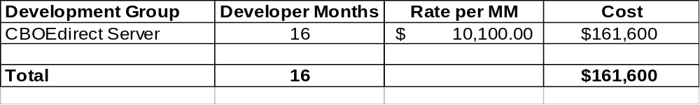

Hardware/Software Costs
No new Hardware/Software costs are anticipated.

Benefits
The main benefit of this project is that CBOE will be able to offer unique functionality to trade and book cross product spreads (Option to Stock only).

Environmental Analysis
It is anticipated the current environment will support the capacity and other requirements of the COB for Cross Product Spreads project.

Schedule and Dependency Constraints
No constraints or scheduling conflicts are currently known for this project.

Resource Skill Needs
In-house resources have the skills necessary to complete the COB for Cross Product Spreads Project.

Product Research
No further investigation of products or vendors will be necessary to complete the COB for Cross Product Spreads Project.

